Games Fleadh:

Art Documentation

Theme: Start With Nothing

Ideas:

1. Vampire Survivors Clone

Assets:

Rifles:

* M4A8



* FK47

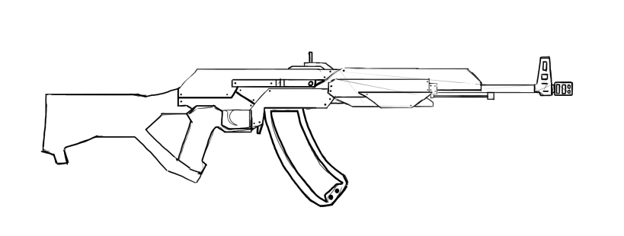

Pistols:

* S&W Nebula X

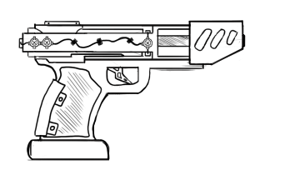

* Aether Eagle AE-50
* A drawing of an object

  Description automatically generated



Shotguns:

-

SMGs:

-

Machine Pistols:

-

Player Character:

* Basic Character Concept
* B Final Character Concept

Effects:

Pickups:

* Health Packs

Screens:

* Menu
* Pause
* Shop
* Upgrade